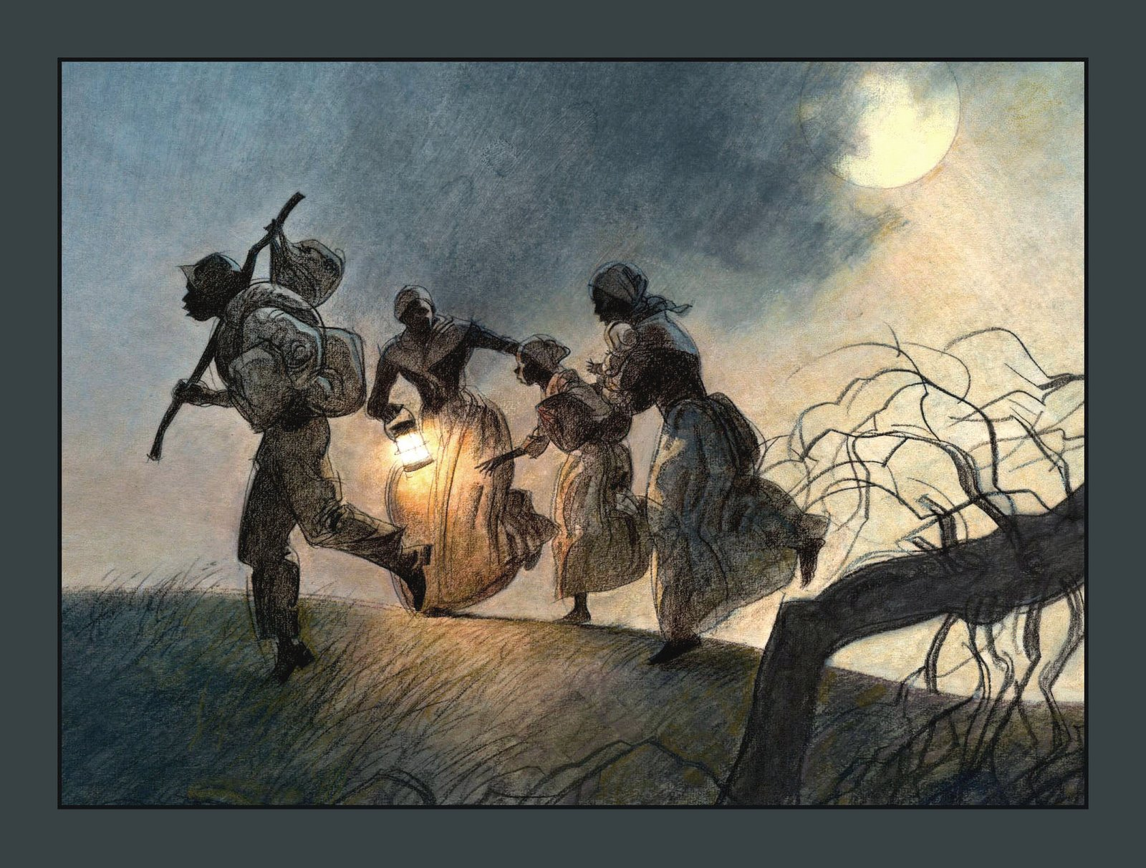

If You Traveled on the

Underground Railroad

(Excerpt)- by Ellen Levine

The Underground Railroad wasn’t a real railroad. It was the secret way to get from the South and slavery to the North and freedom. Sometimes you would ride on a real railroad, sometimes in a horse-drawn cart, sometimes in a fancy carriage, sometimes on a boat, sometimes on horseback. And much of the time you would walk. The whole trip was called the Underground Railroad.

When you traveled in this secret way, you stayed at special hiding places throughout the South and North. Often you had to find your own hiding places. Other times people hid you until you could travel on.

The houses slaves hid in along the way were called ‘stations.’ People who helped the fugitives were called ‘railroad workers.’ The ‘conductors’ would lead you to the next station. Others were ‘station masters’- they would feed you and give you a place to sleep until you left for the next station.

1. Which of the following is *not* given as a way you might travel on the Underground Railroad?

On horseback

In a fancy carriage

In a car

On a real railroad

1. What did the ‘station masters’ do?

Feed the slaves and give them a place to sleep

Hid the slaves

Lead the slaves to the next station

Tell them what to do

1. What do you think the word *fugitives* means?

The houses slaves hid in

Hiding places

Railroad workers

Slaves